Meta ads

**Advantage of Meta Marketing**

* Facebook & Instagram has over 10 million active advertisers with a reach of over 2.11 billion individuals.
* A Facebook & Instagram user clicks on an average of 12 ads every month.
* Facebook & Instagram audiences aged 18-24 spend 75% of their time watching video ads.
* The average conversion rate on Facebook ads is 9.21% across all industries.

**Benefits of meta marketing**

* **Reach a Wide Audience:** With over 2.9 billion monthly active users, Facebook offers one of the largest audience bases from various demographics.
* **Target Specific Audience:** One of the biggest benefits of Facebook advertising is the ability to target and reach your desired audience. Facebook enables advertisers to target particular demographics and audiences based on user data.
* **Retarget your audience:** Facebook platform offers business owners to target ads on people who have previously engaged with their brand. There can be many ways in which people engage with your brand, including- visiting the site, adding products to the cart, filling out a form, or visiting the contact us page.
* **Cost-effective**: Facebook advertising is comparatively affordable, thus, ideal for start-ups and small businesses. It is almost half the cost of traditional advertising.
* **Driving traffic to your website:** Facebook offers a custom Call to Action feature to support to visit your website

**Requirements to run meta ads**

* Facebook Business Page
* Instagram Business Account
* Facebook Page connected to Instagram professional account

Connect facebook with instagram

* Create facebook account.
* Create page----> menu----> pages------> create page----->give name ,mobile number
* Insta----Settings--->Account type and tools---->switch to professional account----->Give category name----->choose business----->give contact information--->skip
* Complete your profile----add link---> add website link
* In facebook page ---->click settings----> linked account---connect account---confirm-----login instagram

Meta business suite , Meta business manager , Meta ads manager

**1.Meta Business suite**

Meta Business Suite is a one-stop shop where you can manage all of your marketing and advertising activities on Facebook and Instagram.

1. View notifications

2. Respond to messages and comments

3. Create or schedule posts, Stories, and ads

4.Access account insights

5.Receive tips, insights, and "goals" to help you optimize your performance

6. Monitor your growth

7.Stay on top of comments and DMs from your audience

8. Get insight into your customers and ad performance

* Google---> meta business suite--->login----ads----next.

**1.Meta Business manager(access)**

Maintain control, security and privacy of your Facebook and Instagram assets by managing your Meta business account on Meta Business Manager.

**Privacy.**Work with your coworkers on Business Manager without having to connect or give them access to your personal Facebook profile.

**Security.**Identify risks and see recommended actions that you can take to improve security.

**Control.**Control and manage access and permissions for all your assets in one place, as your team, agency partners or vendors change over time.

**Efficiency.**Manage multiple assets with batch actions. Track performance across multiple Pages and ad accounts

* Meta business suite
* Go to business manager--->navigates to business manager-----create business account if need------

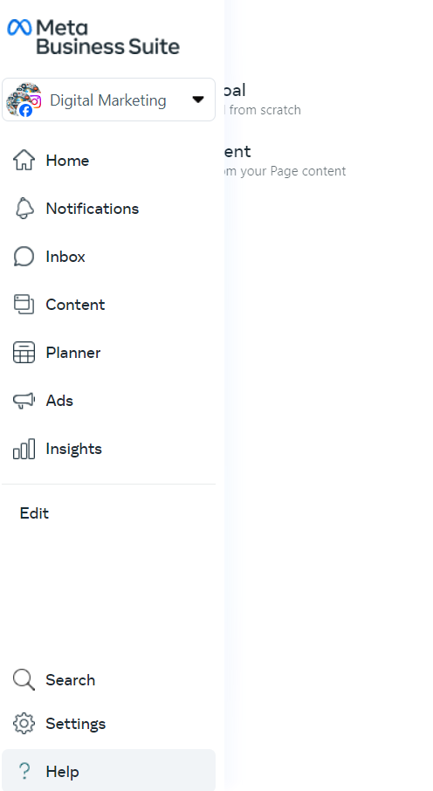

Give access to Ads Manager

* Facebook business manager---->go to business settings--->Add--->Another account id---->add

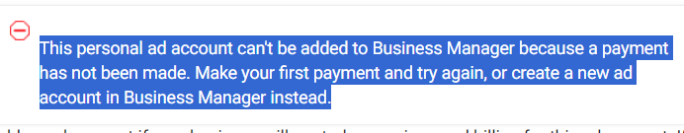

* All tools----> ads manager

Ads manager

Ads Manager is your starting point for running ads on Facebook, Instagram, Messenger or Audience Network. It's an all-in-one tool for creating ads, managing when and where they'll run, and tracking how well your campaigns are performing towards your marketing goals.

1. Create brand new ads.

2. Choose your audience.

3. Set up and manage your ad budgets.

4. Run ads across multiple apps.

5. Adjust your campaigns.

6. Improve performance with dynamic creative.

7. Test which ads perform best.

8. Get real-time insights.

Meta pixel

* The Facebook pixel is a piece of code that you place on your website.
* The Meta pixel helps you optimize your ads and make sure they're shown to the right audience.
* It collects data that helps you track conversions from Facebook ads, optimize ads.
* Meta pixel build targeted audiences for future ads and remarket to people who have already taken some kind of action on your website.
* meta business suite--->all tools---->Event manager----->connect data---->web---->next----->audience name---->create--->give website url---->check---->next---->meta pixel only--->set up manually or data sources---->set up meta pixel----->install manual code---->copy code ----> paste this code in head section---continue---go to pixel overview(takes 1 day for users activity)
* In wordpress, install header footer code manager plugin----hfcm----give snippet name----location-header----display url----site wide----snippet code---paste pixel code---save

Payment method(pre-paid)

* Meta business suite---->all tools----billing & payment----payment settings---add payment method----choose upi---make payment(personal ad account)
* Choose payment methods-----add business payment---add----enter card details.
* Give gst details for different business account----payment settings----business info----give gst number and address of the client

Campaign objectives

**Types Of Campaign Objectives**

* Meta's ad auction is designed to help your ad get the most results possible for your budget.
* You will need to tell our auction system what you want to accomplish with your ad. You can do this by choosing the ad objective that best supports your business goal.
* Meta auction system will look for people across Facebook, Instagram and Messenger who are more likely to take the action related to your ad objective.

1. Sales

2. Leads

3. Engagement

4. Traffic

5. Awareness

6. App promotion

* Meta business suite----->all tools ------>ads manager----->create

**Sales Objectives**

* Find people across Facebook, Instagram and Messenger most likely to purchase your product or service. This objective is best to get new customers and increase sales on your website

This objective is good for:

1. Conversions

2. Catalogue sales

3. Messages

**Lead Objectives**

* Use lead gen ads to gather information from new contacts across Facebook, Instagram and Messenger, and move them through the buying process.

This objective is good for:

1. Instant forms

2. Messages

3. Calls

4. Sign-ups

**Engagement Objectives**

* Engage with more people across Facebook, Instagram and Messenger. This ad type can help you get more messages, video views, post engagement or event responses.

This objective is good for:

1. Messages

2. Video views

3. Post engagement

**Traffic Objectives**

* Send people to a destination, such as your website, app or Facebook event.
* Decide where you want to send people who click on your ad, such as your website, or to start a conversation with your business on Messenger or WhatsApp.

This objective is good for:

1. Link clicks

2. Landing page views

**Awareness Objectives**

* Reach new audiences and stay top of mind with customers across Facebook, Instagram and Messenger.
* Show your ads to people who are most likely to remember them.

This objective is good for:

1. Reach

2. Brand awareness

3. Video views

**App Promotion Objectives**

* Find new people to install your app and continue using it.

This objective is good for:

1. App installs

2. App events

Ads types and ads placements

* We can use different ad formats across Facebook, Messenger, Instagram, WhatsApp and Meta Audience Network including image, video, collection, Carousel and Instant Experience etc

**Meta Ad Formats**

* We can use different ad formats across Facebook, Messenger, Instagram and Meta Audience Network

1. Image ads
2. Lead ads
3. Video ads
4. Slideshow ads
5. Mobile app ads
6. Stories ads
7. Carousel ads
8. Collection ads

**Meta Ad Placements**

1. Facebook Feed
2. Instagram feed
3. Facebook in-stream video
4. Instagram Stories
5. Facebook video feeds ads
6. Facebook Marketplace
7. Instagram Explore
8. Facebook stories
9. Instagram Explore home
10. Ads on Facebook Reels
11. Audience Network native, banner and
12. interstitial
13. Facebook search results
14. Facebook Business Explore
15. Audience Network rewarded video
16. Facebook Reels
17. Messenger Stories
18. Instagram Profile Feed
19. Facebook right column

**Meta Ads Campaign Structure**

We can use different ad formats across Facebook, Messenger, Instagram and Meta Audience Network including image, video, collection, Carousel and Instant Experience etc.

**Campaign level**

* Campaign level is where you set your campaign objective e.g. Sales, Leads, etc..
* Meta's algorithms will take your campaign objective on board and use it to decide who to show your ads to. If your objective is an increase in traffic, for example, Meta will show your ads to users who it thinks are more likely to click links

**Ad Set level**

* At the ad set level, you'll define schedule, audiences and placement. You can also define which 'goal' you want Meta to optimize, for example, you can select 'conversions' as a campaign goal and then choose 'purchase'.
* If you want to target different audiences eg. one lookalike and one broad audience, these would be different ad sets.
* You can create a lookalike audience by uploading a list of your business's customers to Meta and asking it to create a lookalike audience of similar people. This is one of Meta's most helpful features, and it's great for using targeting to ensure a higher conversion rate.Within the ad set level, you'll then have one or more ads

**Ads level**

* This is where you'll add your creatives, tracking and the URL that you want the end user to go to.
* You'll also select which ad you want to create, whether those are image ads, video ads, carousel ads, etc

Facebook-----ads-----campaign---create----advantage campaign budget-------on

Meta Ads

**Campaign Budget**

* A budget is the amount of money you want to spend on showing people your ads.
* It helps control your overall spend for a campaign or ad set, the same way a bid strategy helps control your cost per result.

**Campaign Budgets & Ad Set Budgets**

* You can set an overall budget for your campaign or set individual budgets for your ad sets.

**Campaign Budget**

* You can set one overarching campaign budget that continuously distributes in real time to ad sets with the best opportunities.
* Campaign budgets can simplify campaign setup and reduce the number of budgets you have to manage manually.
* Advantage campaign budget can help you get the most results possible from your campaign at the lowest cost.

**Ad Set Budgets**

* You can set budgets for individual ad sets so can control the amount spent on each ad set.
* While Advantage campaign budget spends your overall budget evenly over the course of your campaign, ad set budgets can be spent as soon as opportunities become available for that ad set.

**Note:** Advantage campaign budget is best suited for campaigns with at least 2 ad sets.

**Campaign Budgets & Ad Set Budgets**

* For both campaign budgets and ad set budgets, you can choose whether your budget applies to each day, or over the entire lifetime of the campaign or ad set.

**Daily budgets:**

* The average amount you want to spend on an ad set or campaign each day.
* Daily budgets are not a hard cap. When you set your daily budget, you're setting an average daily spend over the course of a week.
* They can work well if you want to spend roughly the same amount each day to achieve consistent daily results for your campaign or ad set.

**Lifetime budgets:**

* The total amount you're willing to spend over the entire run-time of your campaign or ad set.
* Lifetime budgets are a hard cap, not an average.
* They can be useful if you don't want to exceed a certain spend amount, and work best if you have flexibility on how much you want to spend each day.

**Note:** It is usually normal to see some fluctuations in spend. For example, daily budgets are an average daily spend over the course of a week, and may fluctuate up to 25% above your budget on some days and less on others

**Facebook A/B Testing**

* A/B testing is a method of comparing two versions to figure out which one performs better.
* Also known as Split Testing

**Select a variable to test**

**1. Creative**

* Understand which creatives your audience is more likely to engage with.

**2. Delivery Optimization**

* Understand which optimization events lead to better results.

**3. Audience**

* Understand which groups of people are more likely to respond to your ads.

**4. Placement**

* Understand which platforms are most effective for your ads.

**Lookalike audience**

If we add already visited users, we target more than 100000 audience with same interest.

* Lookalike Audiences are a way to reach people who have similar characteristics to your existing customers.
* By using a source audience (a Custom Audience), Meta identifies common traits and behaviors of the users in that source audience and finds new people who share similar attributes.

**Type of Lookalike Audience**

**1. Source Audience:**

* Start by choosing a source audience. This can be a Custom Audience based on your customer list, website visitors, app users, or fans of your Facebook page.
* The source audience needs to have at least 100 people from a single country to create a Lookalike Audience.

**2. Location:**

* Specify the country or countries where you want to find your Lookalike Audience. You can create Lookalike Audiences in multiple countries, but they will be separate audiences.

**3. Audience Size:**

* Choose the size of your Lookalike Audience. The size ranges from 1% to 10% of the total population in the target country.
* A 1% Lookalike Audience consists of the people most similar to your source audience. As you increase the percentage, the audience size grows, but the similarity to the source audience decreases